Step-1: Physical Connection.

Take One Switch and Multiple PC’s.Now Connect them using Copper Straight Connection Cabel.

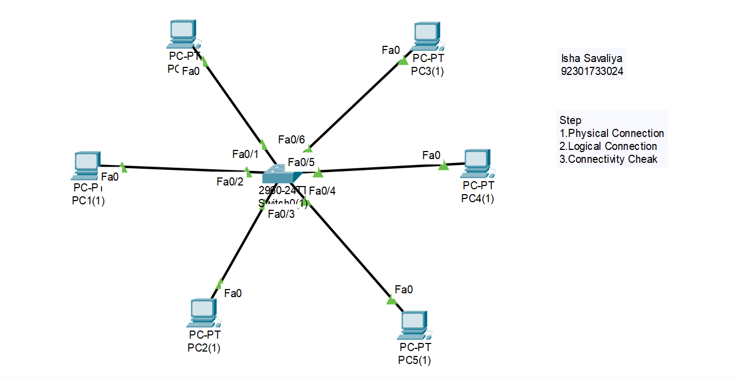

Step-2: Logical Connection:

Now Configure all the PC’s with Different IP Address and Same subnet mask

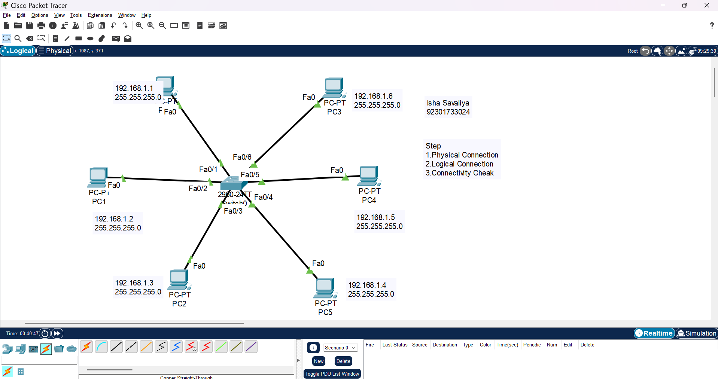

Step-3: Connectivity Check

Now open command prompt of any one of that PC’s.Now run command “ping ip_address” where ip_address is your destination ip address.

